Proposed Tree Planting Initiative in Edgemont: April 20, 2021

The Edgemont Community Association was advised of a planned City of Calgary tree planting initiative in Edgemont. On April 19th we were given final information on this project and a timeline. Planned construction is scheduled to begin in May with tree planting in June. Given the short timeline the community association cannot engage in meaningful consultation with the residents prior to construction start. Affected residents will be advised of the project by flyers and by our webpage and can give comments to the city via 311, directing their comments to the Calgary Urban Forest department.

We did find one useful link from Ward 9 which gives a good description of the project timeline. The Covid 19 pandemic appears to have delayed the project by a year as the trees were supposed to be planted in 2020.

Urban Forestry Canopy Expansion Program — Ward 9 Great Neighbourhoods Calgary – Gian-Carlo Carra (gccarra.ca)

Attached are the locations of the planting and cross sections reflecting existing conditions and future conditions.

The elevations reflect a tree height maximum of 40 feet.

The maximum height could be achieved under perfect environmental conditions, it is predicted that the 40 foot height will not occur.

Maximum height of the trees would be realized in approx. 50 years.

Calgary Parks are planning a mix planting of Saskatoon, Amur Maple, Pine, White Spruce, Larch, Green Ash and potentially some under story shrubs. The trees are 6-12” when they are installed, and the average growth rate is 6”/yr.

Details & proposed timeline for EDG224 park site:

- May: Planting area will be mechanically prepped with compost from WRS
- May: A temporary fence installed to secure planting area
- June: Trees installed
- June: Hemp matts & grass seed installed
- June-Oct: Seedlings will be watered using a water truck

Details and proposed timeline for EDG097 road right of way site:

- May: Planting area will be mechanically prepped with compost from WRS
- June: Trees installed
- June: Hemp matts & grass seed installed
- June-Oct: Seedlings will be watered using a water truck

This planting initiative is a result of:

“Urban Forestry has been mandated by council to supply & install 100,000 tree seedlings on Roads Right of Ways, Parks, and Natural Areas throughout the City; increasing our Urban Canopy, is a key contributing factor for decreasing the City’s Carbon foot print as, “one tree planted can sequester as much as 48 lbs of carbon/year.” (https://savingnature.com/offset-your-carbon-footprint-carbon-calculator/).”

This project will have positive benefits and potential drawbacks for the residents of Edgemont, please review the information and relay any concerns or support for the project to 311.
Project benefits:
- Carbon capture
- Sound attenuation
- Beautification and naturalization of a slope and road right of way
- Increased animal habitat

Project drawbacks:
- Potential blocking of views from homes in the long term
- Failure of forest to establish leaving an unsightly mess in the short term

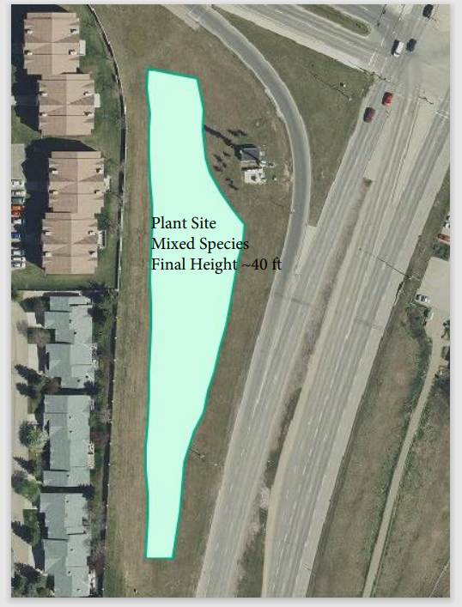
Shaganappi Location
Profiles show the topography along a cross-section and the layers on the tree block represent the trees at different heights over time so you can see the impact of the trees on views. In cross section 1 towards the buildings is the berm and fence atop it which limits views, the trees will be visible above this when they have grown to a height of 20 feet which will be in about 20 years, at that point they will start obscuring the view. In cross section 2 the view is already obscured by trees, homes, and the berm and the forest would have to be 30 feet tall to impact the view.
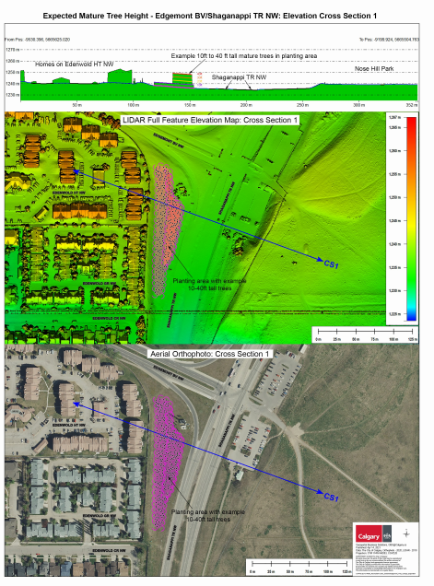
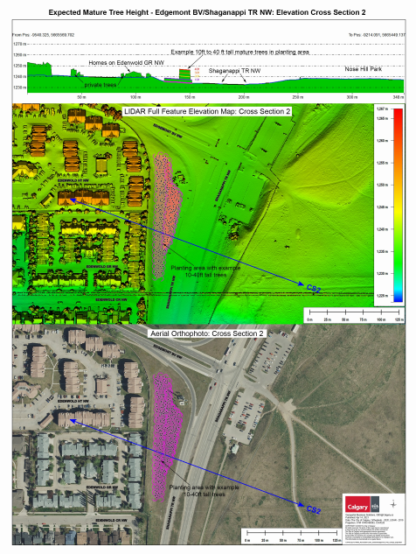
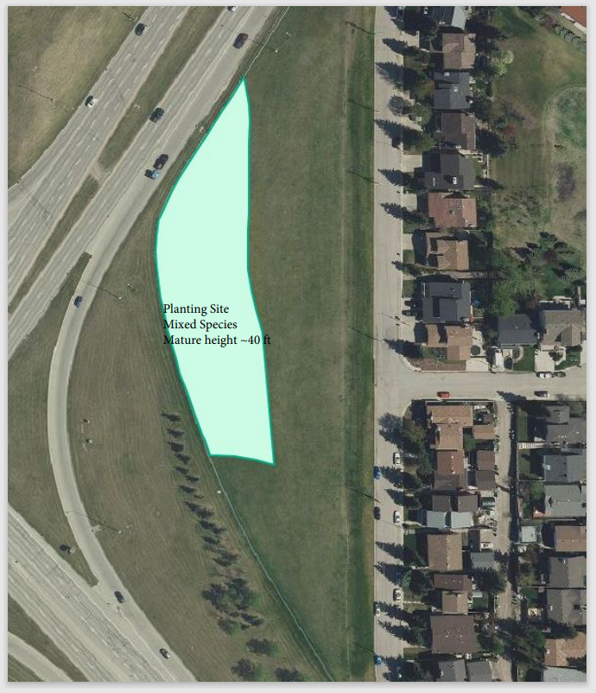
Sarcee Location

Cross section 1 shows the view of the intersection will be obscured when the trees have reached 10 feet of height, at full height of 40 feet the view of the hills across the intersection will be partially blocked from the homes and the mountain view should be visible. Cross section 2 indicates the view of the hills across the intersection will be fully blocked at 40 feet of growth and the mountain view may be impacted.
