Disc Golf Project Historical Documents

Project timeline
2019:
- brainstorming ideas for new park features for Edgemont
- develop concept
- reach out to City to determine if there were any suitable areas in Edgemont that could accommodate a course
- work with disc golf community to develop a course layout

2020:
- continue to work with disc golf community and City to develop plan
- finalize review of park areas in community and pick best location for course
- newsletter articles informing residents of initial plan asking for feedback
- lay out original course with flags
- consult with residents and City and other stakeholders
- respond to all correspondence, both positive and negative
- adjust course, set up a temporary course (this was done in June, the temporary course is still set up and being used)
- repeated rounds of communication with residents via meetings on site and newsletter and social media articles,
- continue to respond to all correspondence
- testing and tracking of usage, done through UDisc app and emails sent from users
- settled on a course layout for the most part (11 hole course) . When course layout was modified safety was at the forefront of all design changes
- begin exploring fund raising options

2021:
- continued fund raising, still in fundraising stage
- work towards final layout of course,
- make final decisions on style of baskets, launch pads,
- investigate construction timing around city trench,
- prepare project construction timeline.
- final presentation to community at large via webinar,
- prepare rfp for project and get multiple bids for construction,
- finalize budget and prepare contract,
- get final approval from board and issue contract,
- finalize timeline,
- advise community of impending construction (likely August or Sept)
- build facility,
- have a grand opening ceremony

Historical Documents

The board passed a motion in April of 2019 to install a temporary disc golf course in Reservoir Park

Edgemont Disc Golf Course – Update October 2019
Based on conversations with the City of Calgary we have determined that the best location to install a Disc Golf course in Edgemont is on the top of John Laurie Park. The course would start at the paved parking lot, circle around the tennis courts, permitted playing fields, unpermitted playing fields and then finish back at the paved parking lot.
There is currently a meeting scheduled between the Disc Golf committee, City representatives and the Calgary Disc Golf Association on Thursday, October 24th at noon at the John Laurie paved parking lot. At the meeting we will be walking the proposed site and sketching out some course design. If you would like to attend this meeting, please feel free to join.
Moving forward we would then start the phase on community consultation and funding requirements. Ultimately we would like to have residents on board and a funding model in place in order to have the course built in the spring of 2020.

Edgemont Disc Golf Course
- Located at the corner of Edgemont Drive and Edgemont Blvd. Parking lot is by the baseball diamond
- 51°06’56.6″ 114°09’06.7″
- 11 tone targets. which may be transitioned to a basket course
- Natural tee pads
- Establish 2020 by the Edgemont Community Association
- Disc Golf is being evaluated as a permanent course depending on feedback

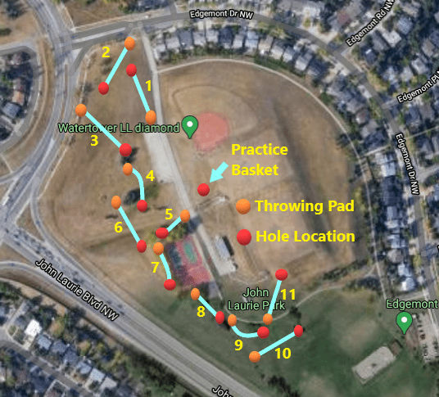

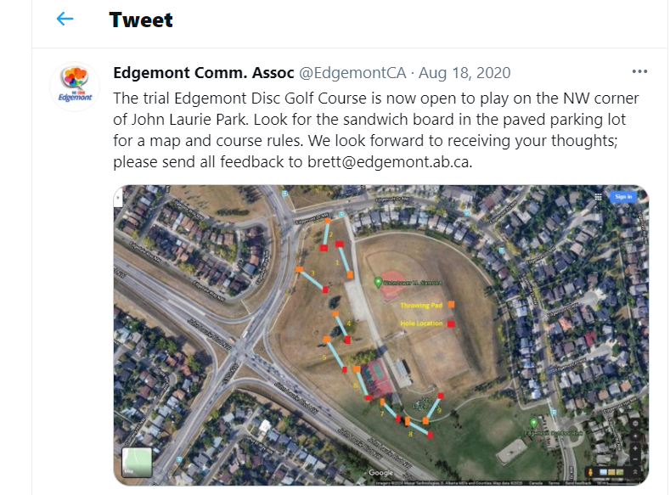

Newsletter Articles, 2020, 2021, 2019 newsletters not available
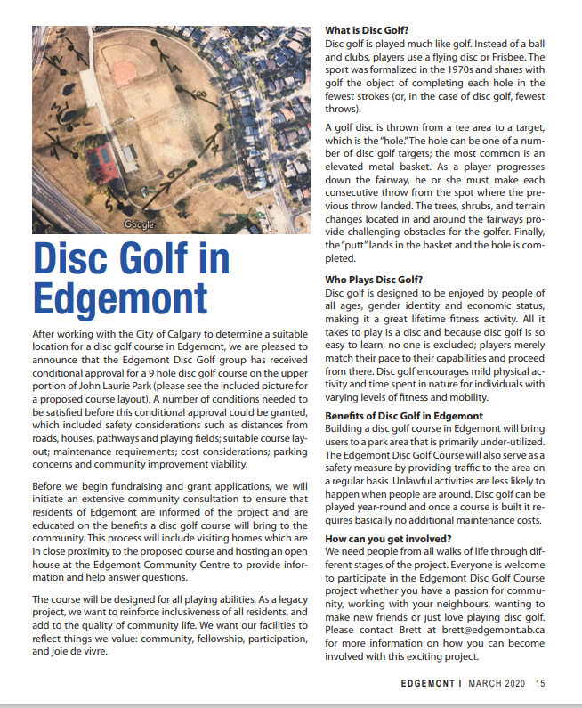
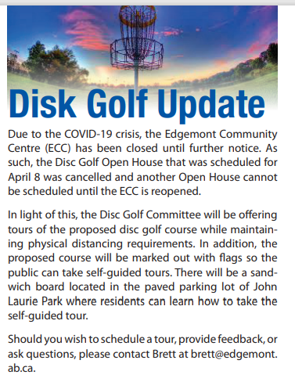
June 2020
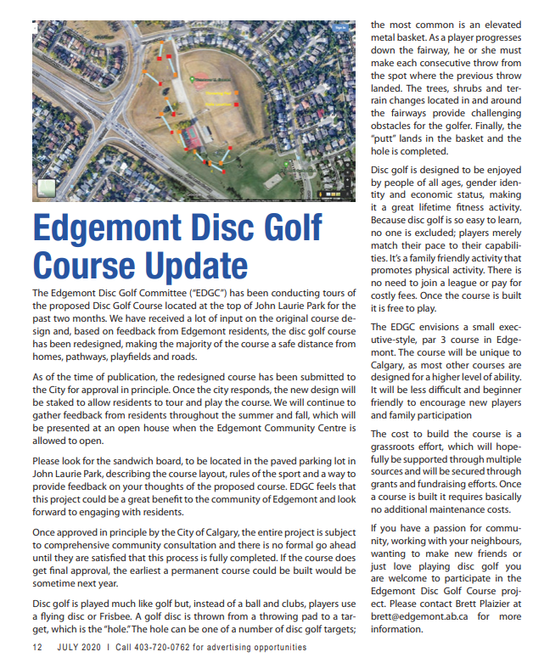
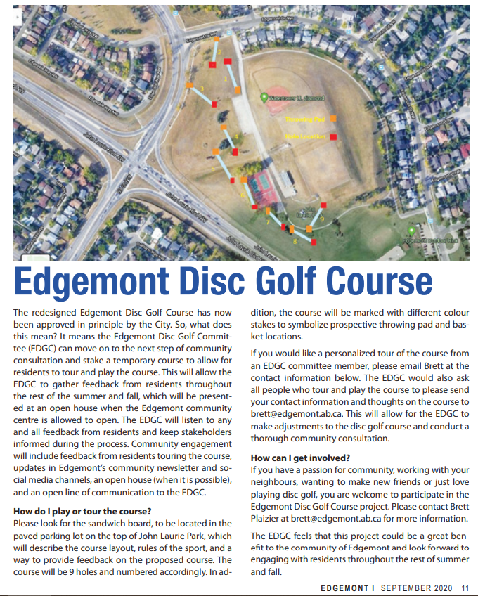
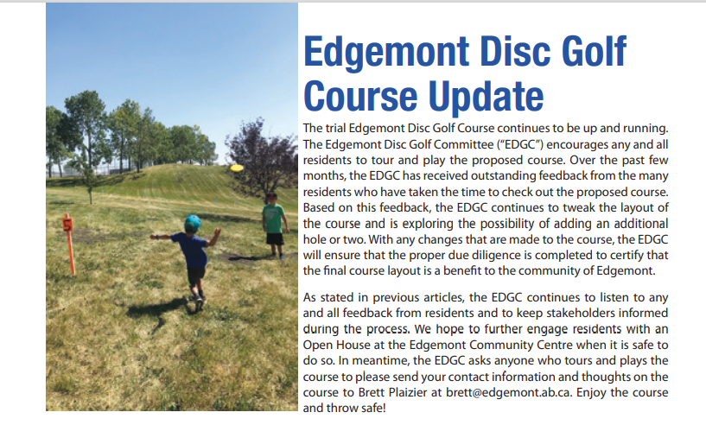
October 2020
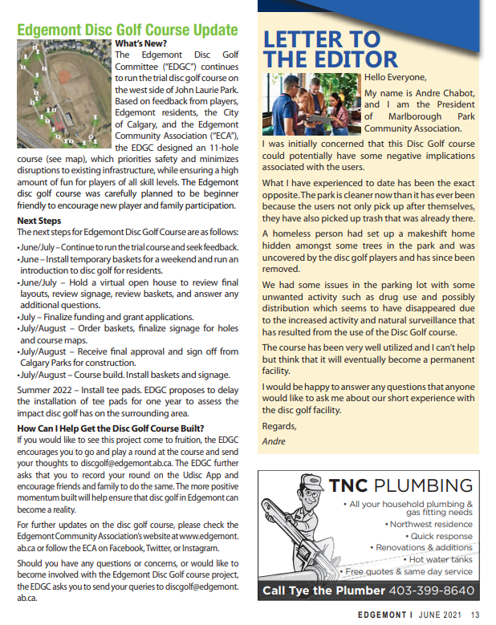

AGM Reports
2020 AGM
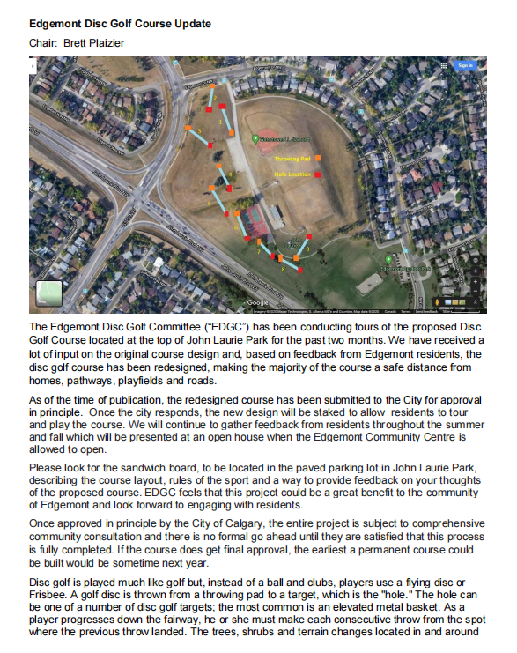
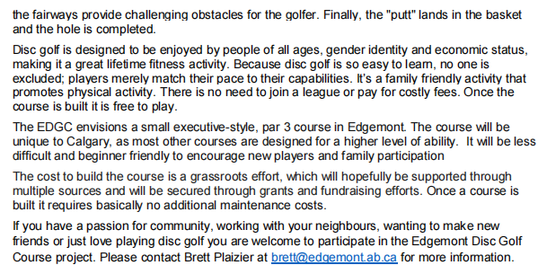
2021 AGM

Edgemont Disc Golf Course AGM Update What’s New? The Edgemont Disc Golf Committee (“EDGC”) continues to run the trial disc golf course on the west side of John Laurie Park. Based on feedback from players, Edgemont residents, the City of Calgary and the Edgemont Community Association (“ECA”), the EDGC designed an 11 hole course (see map), which priorities safety and minimizes disruptions to existing infrastructure, while ensuring a high amount of fun for players of all skill levels. The Edgemont disc golf course was carefully planned to be beginner friendly to encourage new player and family participation. Next Steps The next steps for Edgemont Disc Golf Course are as follows:
• June/July - Continue to run the trial course and seek feedback.
• June - Install temporary baskets for a weekend and run an introduction to disc golf for residents.
• June/July - Hold a virtual open house to review final layouts, review signage, review baskets, and answer any additional questions.
• July – Finalize funding and grant applications. EDGC has secured $17,500 in grants. $10,000 from Parks Foundation and $7500 from Calgary Foundation.
• July/August – Order baskets, finalize signage for holes and course maps.
• July/August – Receive final approval and sign off from Calgary Parks for construction.
• July/August - Course build. Install baskets and signage.
• Summer 2022 – Install tee pads. EDGC proposes to delay the installation of tee pads for one year to assess the impact disc golf has on the surrounding area.
How can I help get the Disc Golf course built? If you would like to see this project come to fruition, the EDGC encourages you to go and play a round at the course and send your thoughts to discgolf@edgemont.ab.ca. The EDGC further asks you to record your round on the Udisc App and encourage friends and family to do the same. The more positive momentum built will help ensure that disc golf in Edgemont can become a reality.
For further updates on the disc golf course, please check the Edgemont Community Association’s website at www.edgemont.ab.ca or follow the ECA on Facebook, Twitter or Instagram. Should you have any questions or concerns, or would like to become involved with the Edgemont Disc Golf course project, the EDGC asks you to send your queries to discgolf@edgemont.ab.ca.

